**Be Safe Booklet**

**Making Safeguarding Personal**

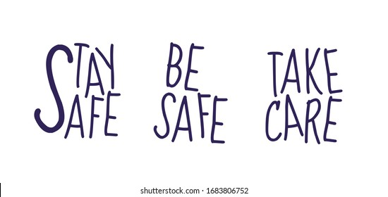

**This booklet is about being safe from abuse.**

**What is abuse?**

Abuse is when someone hurts you or treats you badly.

Abuse happens when someone has power over you, and you do not agree to what is happening to you.

You might feel too scared to speak out or stop them. It can make you feel angry, sad or frightened.

**It is important that you speak out and tell someone.**

**At We Change Lives we make a Promise to the people who use our services:**

* We will treat you with respect and dignity and support you to stay safe.
* We believe that everyone deserves respect.
* Respect values the differences that make people individual and does not accept discrimination or offensive behaviour.
* Respect helps people feel safe, so aggressive behaviour and offensive language is not acceptable.
* Respect requires us to help each other to maintain personal dignity.

**Abuse can happen anywhere**.

[](http://www.bing.com/images/search?q=clip+art+Sad+Old+Person&view=detailv2&&id=19354D2424857275858DCCAEEA2034CC75C19D64&selectedIndex=49&ccid=1ozM9X%2bq&simid=608037198499807893&thid=OIP.Md68cccf57faa218d16c582f5218c9df3o0)Abuse might happen where you live, spend your day or when you are out and about. You might be abused by someone you know like a carer, family member or friend. You might be abused by a stranger. Abuse can happen on purpose and the person knows it is wrong.

Sometimes the person abusing you might not know that what they are doing is wrong. Remember abuse is always wrong.

Things can get better if you tell someone.

**You have the right to feel safe and keep safe.**

You have the right to speak up and get help. This is called advocacy.

There are different kinds of abuse.

 Physical abuse

* This is when someone hurts or treats you roughly.
* They might hit, kick, push, scratch or punch you.
* Someone might not give you your medication or give you too much.
* **Physical abuse is wrong.**

Sexual abuse

* This is when someone touches your body in ways you do not like or want.
* They might touch you when you don’t want to be touched.
* They might have sex with you when you do not want them to.
* **Sexual abuse is wrong.**

[](http://www.bing.com/images/search?q=image+of+pounds&view=detailv2&qpvt=image+of+pounds&id=EC6BCF7D91F2D5AFB558E9302A953131B1D50E09&selectedIndex=19&ccid=ZN/mUhap&simid=608054734846627389&thid=OIP.M64dfe65216a9e98bc58b1c0214817a9ao0)**Financial abuse**

* This is when someone takes or uses your money when you don’t want them to.
* They might steal your money or force you to pay for other people’s things.
* Sometimes it might mean that you don’t have a say in how your money is spent.
* This might be if you lend someone money and they don’t return it. This is when someone takes your credit card and spends on it.
* **Financial abuse is wrong.**

**Emotional abuse**

* [](http://www.bing.com/images/search?q=teddy+covering+his+eyes&view=detailv2&&id=D6EA51D046BF239F8DCD0FE23F93C8812D4C4B99&selectedIndex=0&ccid=RoF9F%2blO&simid=607993372646769793&thid=OIP.M46817d17e94ea5f11680a67c7af336d4o0)This is when people talk to you in unkind ways and say nasty things.
* They might yell or swear at you or sometimes they might ignore you.
* They might tease you or call you names.
* Sometimes they might treat you like a child.
* **Emotional abuse is wrong.**

**Neglect**



* This is when the person who is supposed to be looking after you doesn’t support you properly.
* They might not give you enough food or drink.
* They might not help you to stay warm or look after yourself.
* Sometimes it might mean they do things that put you in danger.
* **Neglect is wrong.**

**Discrimination**



* This is when someone makes fun of you or treats you unfairly because they think you are different to them.
* They might say or do bad things to you because of how you look, act or speak.
* They might treat you unfairly because of your disability, religion, sexuality or colour of skin.
* They might be unkind to you because of who you are.
* It might be name calling by people in the street.
* **Discrimination is wrong.**

**Your rights**

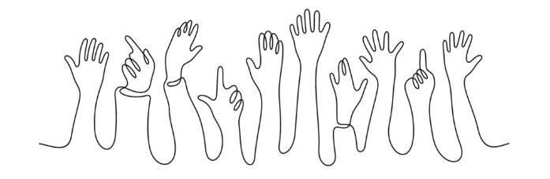

* You have the right to feel safe and keep safe where you live.
* You have the right to feel safe in your own home.
* You have the right to feel safe when you go to town.
* You have the right to feel safe when you go on a bus.
* You have the right to feel safe when you go to appointments.
* You have the right to feel safe and keep safe when you are with friends, family or people whose job it is to support you.
* You have the right to speak up if something is happening to you that makes you frightened, hurt, angry or sad.
* You have the right to be listened to and to be taken seriously.
* You have the right to be treated with dignity and respect.
* You have the right to good support to help you feel safe and keep safe.

**You have the right to be kept safe from abuse.**

**What to do if you are worried? Talk to someone.**

It is important you tell someone you trust as soon as you can.

It is important you get the right help and support to stay safe.

You can talk to a friend, neighbour, advocate, social worker or someone at We Change Lives who supports you such as your Service Manager or a Support Worker.

You can also tell one of our Central Management Team:

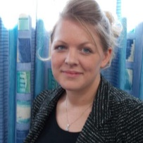Sarah Gardner our Head of Care on **01925 972635** or **07814973964**

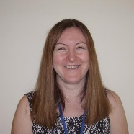Sarah Battersby our Safeguarding Manager on **01925 972635** or **07391416896**

Don’t ignore what is happening. Talk to someone. Things can get better if you report it. If you are worried that a person who is supporting you cannot be trusted then you can always speak to another Manager in WCL or speak to any of the organisations below. This is called **Whistleblowing.**

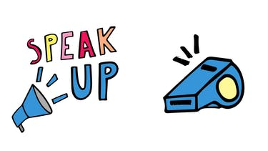

**Report it**

**Access Social Care** (Warrington Borough Council)

They will listen to you and help you get the right support. Safeguarding services will help you to keep safe.

**01925 444 239** (weekdays between 8.30am and 5pm)

**01925 444 000** (after 5pm and weekends)

**Police**

They will listen to you and help you. **999** (in an emergency) **101** (anytime)

**You have the right to report abuse. You have the right to feel safe and keep safe.**

A safeguarding alert may lead to an investigation. An investigation could happen if there are other people at risk of abuse even if you do not want it to. An investigation is to:

* Find out what happened.
* Help the person who has been abused to stay safe.
* Help the person decide what they want to happen in the future.

An investigation could take a long time, or it could take a short time. It is important that we tell you what is happening.

**Our Promise to You**

* We will listen to you and take what you say seriously.
* We will understand that this is a difficult time for you and we will be kind to you.
* We will respect your choices and your right to change your mind.
* We will be honest with you about what we can and can’t do.
* We will invite you to any meetings at a place and time you can get to.
* You can tell us who you want to come to the meeting.
* We can help you access support to help you understand what is happening and to tell people what is important to you. This is called **Advocacy.**
* We will keep you informed and help you understand what is happening at every stage.
* We will do this in a way that you choose.
* We will introduce you to people from other organisations that might need to be involved.
* We will make sure you understand everyone’s role.

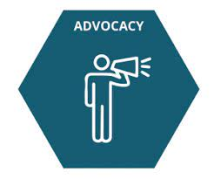What is **advocacy**? **Advocacy** is about making sure that people can tell other people and services about what they need and what they want. Most people can speak up for themselves, but sometimes we all need some help. An **advocate** does not tell you what they would do: they help you to decide what you want.

In Warrington, we can be supported by Warrington Speak Up: <https://www.warringtonspeakup.org.uk/>

Telephone number: [01925 246888](tel:01925246888) Email address: [info@advocacyhub.org.uk](mailto:info@advocacyhub.org.uk)

Address: The Gateway, 89 Sankey Street, Warrington, WA1 1SR

There will be different advocacy services in other areas.

**Keeping Safe out and about**

You could ask someone to be with you.

You could ask your support worker to make a card for you that asks for help if you don’t feel able to speak out.

You could use the safe spaces scheme.

**Safe Places Scheme**

Safe Places will help you if you are scared or lost in town.

A safe place helps vulnerable people if they feel scared or at risk while they  
are out and about in the community and need support right away.

See website: <https://www.safeplaces.org.uk/> or we can help you download the App onto your mobile phone.

**What our Bespoke Group say about this booklet?**

*It’s important to be safe.*

*It's easy to say nice things to people but it's harder if you want to say you are unhappy.*

*It’s harder to feel safe if you don’t know the area.*

*Sometimes it's nice to have someone with me.*

*It's important to know who to speak to if you are afraid.*

*I know a Safe Space in Warrington is the Gateway*

**Thank you to all the people we support who have helped us put this booklet together.**

